Symbols for Use with Tier 2 and Tier 3 Reading Guides
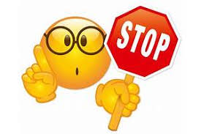 | - At this point, you should stop to answer questions related to the text you have just read.
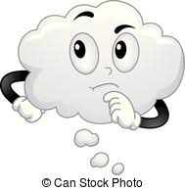 | - Think critically about particular aspects of the text. Additionally, think about how different portions of the text, or previously read text might relate to the question. Make inferences.
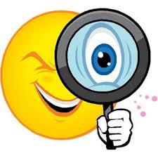 | -Look closer at the text and use your visualization strategies.
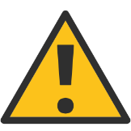 | - Look at additional resources such as a chart, graph, definition, etc.
 | -Briefly illustrate images that this text brings to mind. Illustrations should include elements of imagery pertaining to the senses.
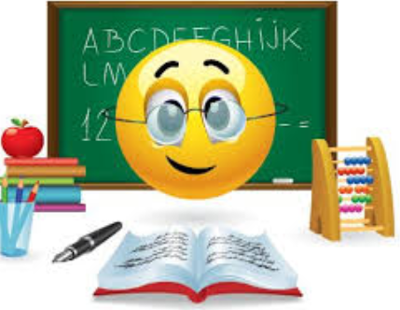 | - Analyze vocabulary for meaning, context, connotation, denotation, etc. Ask yourself why did the author chose this specific word, and how is it used in context.
 | - Read and reread the text for clarification.

